Expression of Interest
for Spectrum Foundation funding
Fill in this form if:
- You run an organisation or programme.
- You work in disability.
- You want to ask for some funding.
- The ‘funding’ is some money from Spectrum Foundation.
Type your answers in the boxes below.
- What is your:
Name:
Phone number:
Email:

- What is your:
Organisation name:

3.
- What is your organisation’s goal or purpose?

b. How does it help people living with disability?

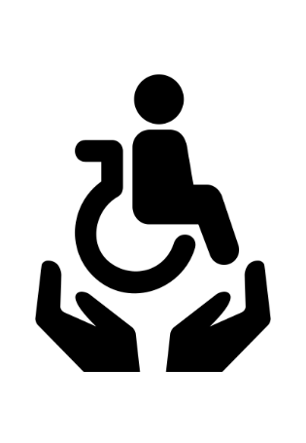 | - What is the name of the programme you want funding for?
- We want to support activities that are sometimes hard to access.
- Tell us about your programme.
- Tell us why you need money.

 | - What group of people are you helping?
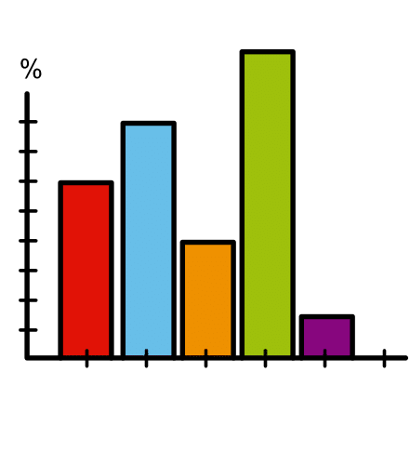 | - What will the results of your programme be?  - How will you know the results?  If your programme has already started:  - How has it helped people?  - Do you have any information to show how it helped?  Write your answer in 150 words or less.
 | - How much funding or money do you need?
- What would you do with the money?
- How will it help?

10.
a. When will the programme start?
b. When will the programme finish?

If you do not know, you can say what you think.

Thank you. Please email this form to: info@spectrumfoundation.org.nz

